Software Development
User Manual
History
Date | Author | Version
 | Romina R. Jimenez | 1.1

Patient Info
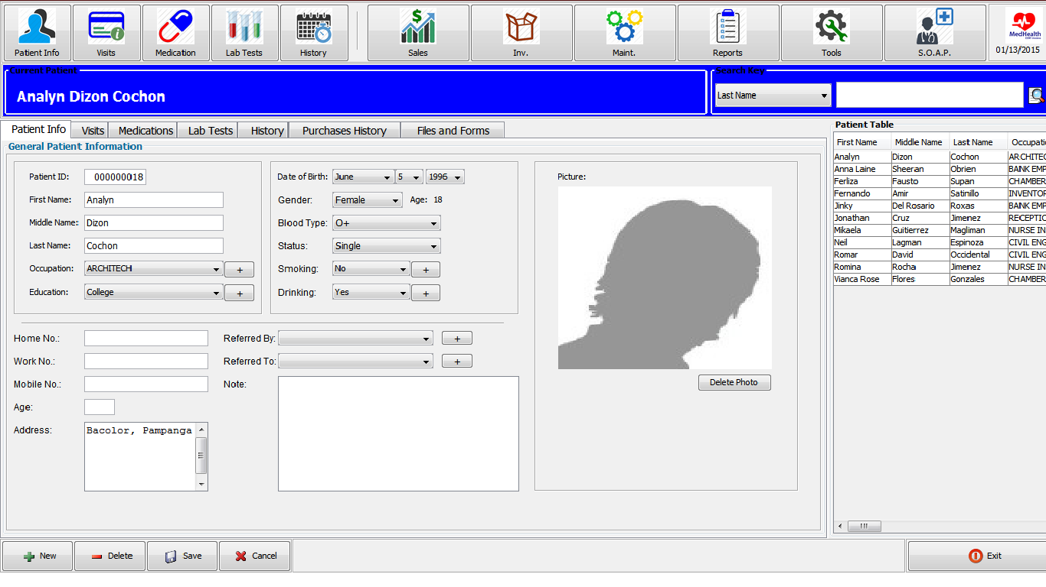
To Add New Patient
• Click New
• Enter the necessary information
• Click Save
To Delete Existing Patient
• Select Patient from “Patient Table”
• Click Delete
• Confirm Deletion and Click “Yes”

Visits
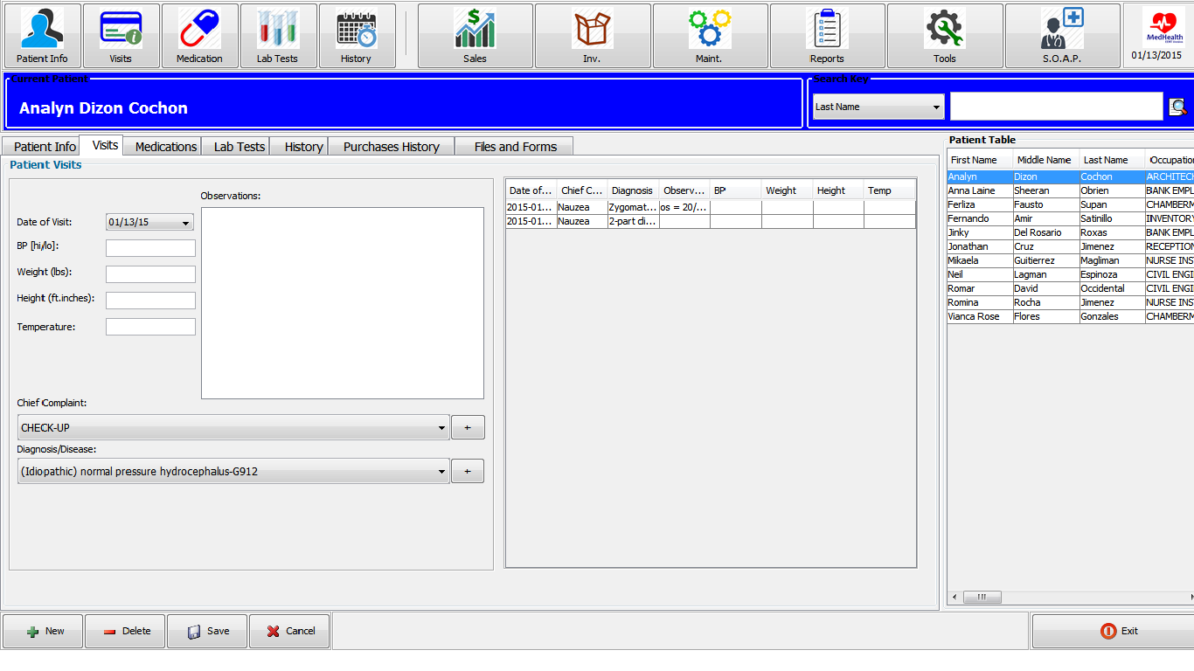
To Add New Visit
• Click New
• Enter the necessary information
• Click Save
To Delete Existing Visit
• Select Entry to be deleted
• Click Delete
• Confirm Deletion and Click “Yes”

Medications
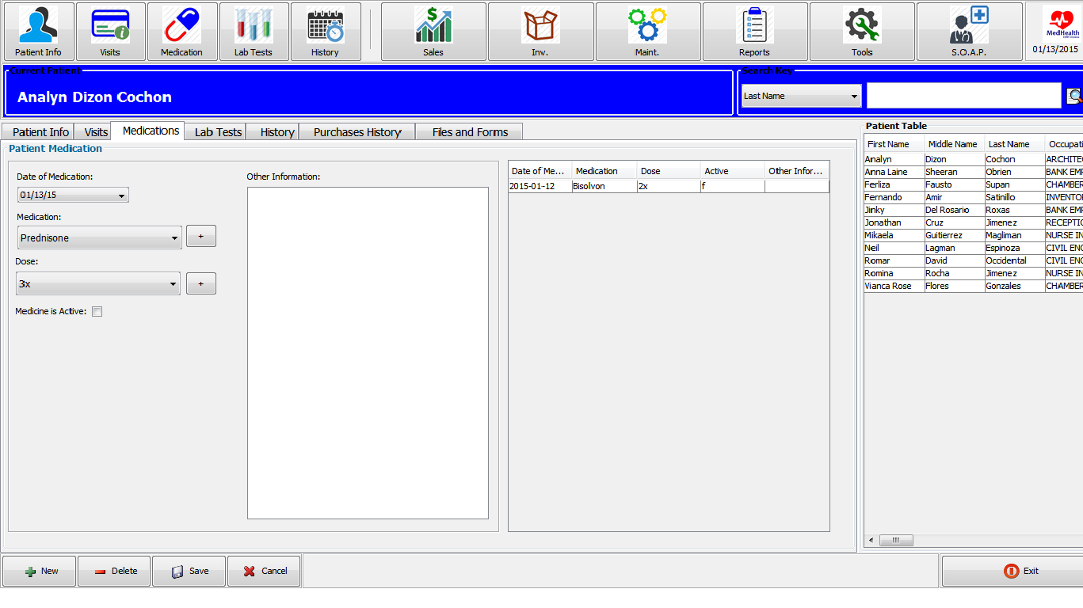
To Add New Medication
• Click New
• Enter the necessary information
• Click Save
To Delete Existing Medication
• Select Entry to be deleted
• Click Delete
• Confirm Deletion and Click “Yes”

Lab Tests
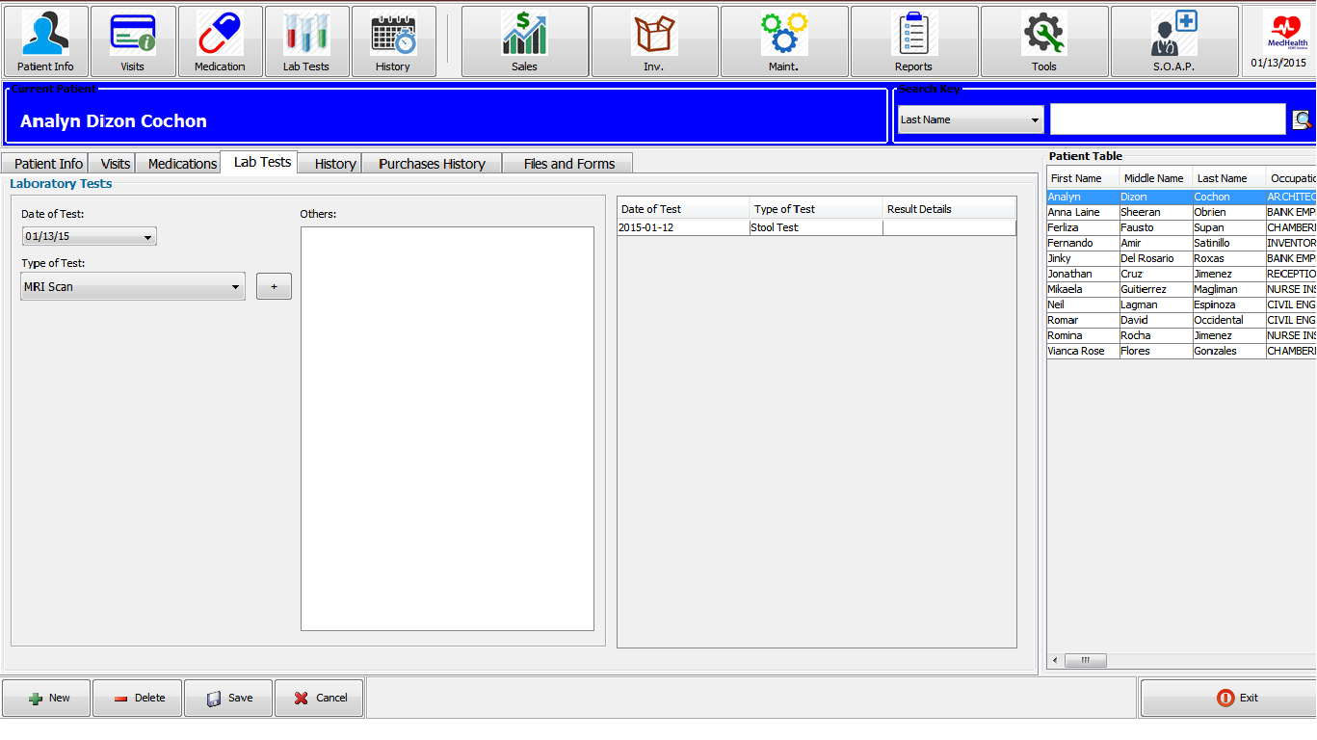
To Add New History
• Click New
• Enter the necessary information
• Click Save
To Delete Existing Lab Test
• Select Entry to be deleted
• Click Delete
• Confirm Deletion and Click “Yes”

History
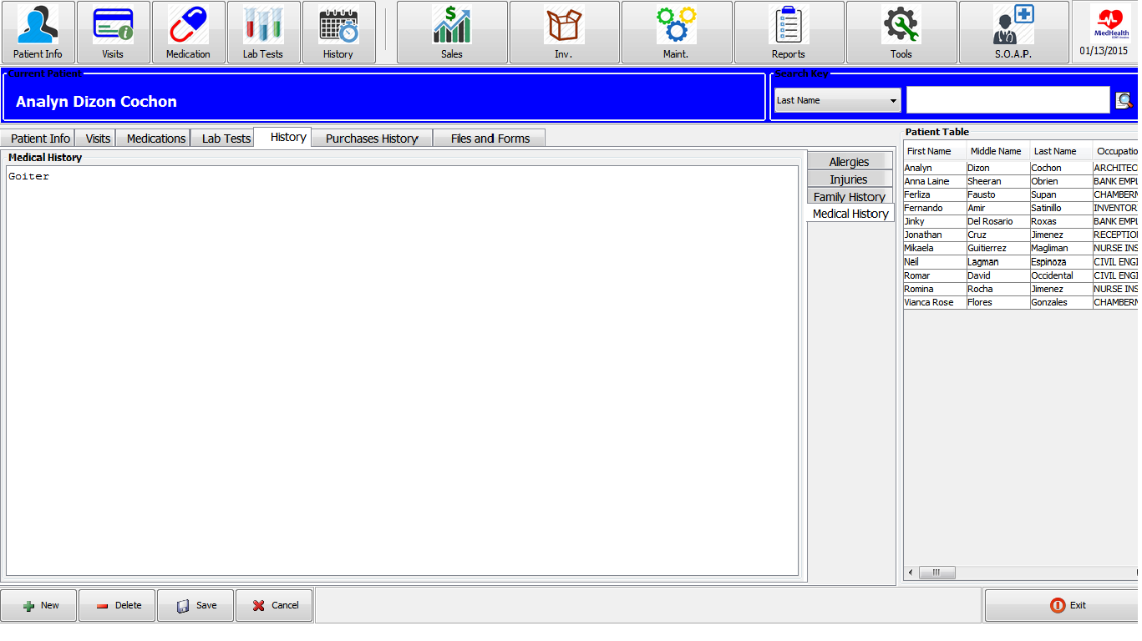
To Add New History
• Select Allergies, Injuries, Family History or Medical History Tab
• Enter the necessary information
• Click Save
To Delete Existing History
• Click Delete
• Confirm Deletion and Click “Yes”

Files and Forms
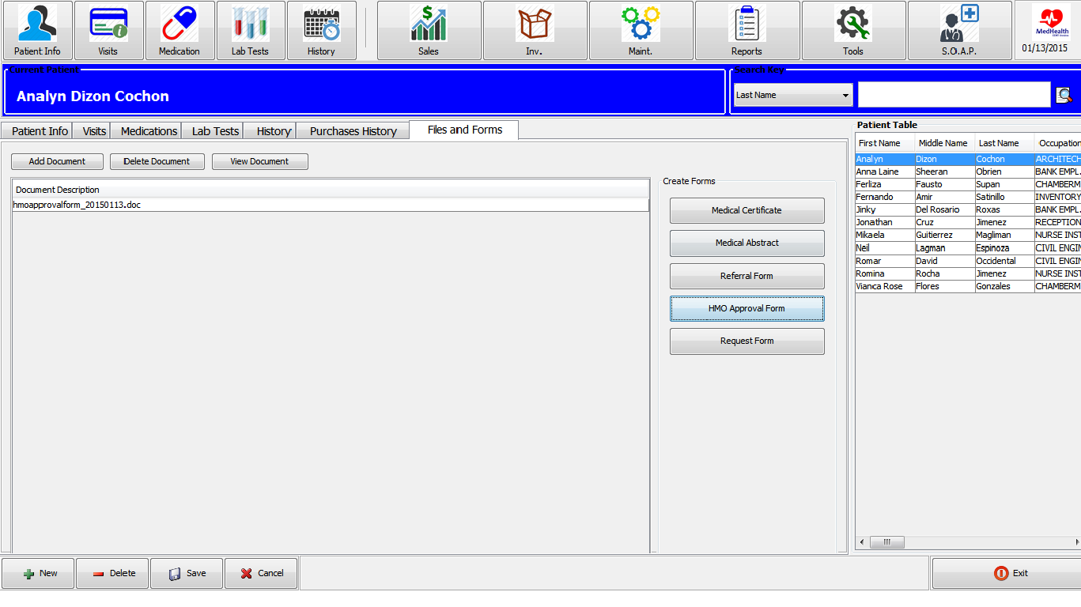
To New Files and Forms
• Click New
• Select the necessary files and forms
• Click Save
To Delete Existing Files and Forms
• Click Delete
• Confirm Deletion and Click “Yes”

Maintenance Menu
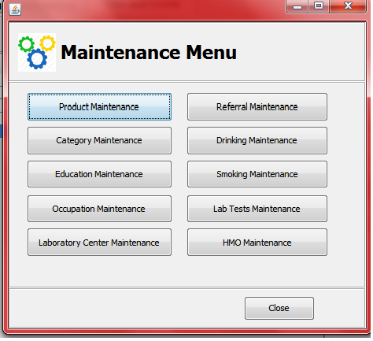

Product and Service Maintenance

